Rick Sullivan
30 September 2014

Audience Analysis

Overview
The senior design report and oral presentation provide unique challenges in addressing audiences that include people of vastly different technical backgrounds. My report and presentation will explain technical details in methods accessible to all subgroups of the audiences. These groups are identified below.

The Design Report
The audience for my written senior design thesis may include the following groups:
- My advisor
- Other engineering faculty
- Students who may continue the project in the future
- Potential investors
- Patent attorneys
- Other interested members of the University

Each of the groups listed above will have a different knowledge base concerning Computer Engineering topics. The range of exposure to technical topics is illustrated in Figure 1 below. In order to effectively communicate to each group, the design report will contain both necessary technical details and intuitive explanations. Intuitive examples and diagrams will ensure that non-technical readers can grasp the major concepts of the report.
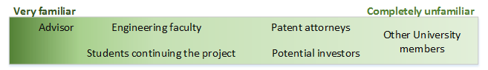Figure 1: Design report audience familiarity with my topic
The Oral Presentation
The oral presentation provides additional challenges due to the short format and varied audience. Some audience members will have very limited technical knowledge. The expected audience will include some or all of the following groups:
- My advisor
- Other engineering faculty
- Industry experts and judges
- Students presenting in the same group
- Other interested students
- Friends and relatives

These audience members span the entirety of the technical knowledge spectrum, as illustrated in Figure 2.
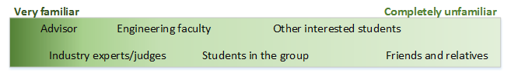Figure 2: Oral presentation audience familiarity with my topic
In order to effectively convey the significance of my project in the oral presentation, I will omit most technical details in favor of diagrams and demonstrations. By demonstrating an important use case in person, both technical and non-technical audience members can understand the applications and impact of my project.

